**Workshop 1 – Slutlig inlämning**

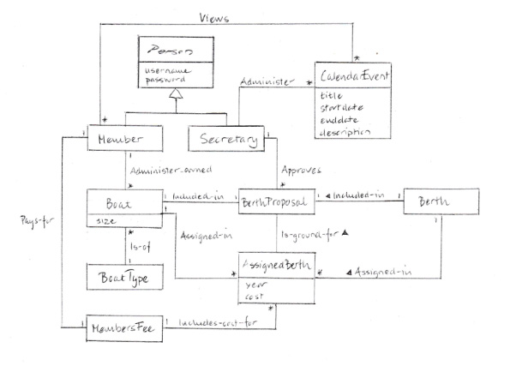

*Changes after review:*

*I got good points in the reviews. I haven’t changed a lot though it got me thinking and I’m not 100% of my choices. As both groups commented on my choice of having size and unit as two conceptual classes I thought it might be too detailed for this iteration so I added size as an attribute for Boat instead even though it’s not a primitive data type. (My earlier choice was based on what Larman said as a guideline for modeling Quantities and Units). I also added BoatType as a conceptual class. I just forgot to draw it in previous model. I didn’t mean to omit boattype but the different types (subclasses such as sailboat, motorboat etc).*

*I also got a comment of my use of super and subclasses for Person, Member and Secretary that it doesn’t belong here rather in the implementation perspective. I would appreciate you view on that as one of the hard parts of domain modelling was to think about the real world and not of the system.*

I assumed that a person needs to be authenticated to be using the system so I made Person an abstract conceptual superclass. I included the subclasses Member and Secretary as they are of interest in this iteration. Treasurer and Cashier are excluded as they don’t add anything extra to the domain model in this iteration. I added the attributes username and password for person as they are needed in the authentication use-case.

A member administers his/hers own boats and can register, alter or delete information. A member also pays a members fee which includes cost for assigned berths.

For the Boat I added Size and Unit at separate conceptual classes as I assumed size of a boat can be given in different units.

A member can also view CalendarEvents. I added the association view zero or many to cover the use-cases where the member views either a list of CalendarEvents or a specific event.

For the class BoatType I didn’t add the different types (sailboat etc) as I didn’t think they added anything more of value in this iteration and as they don’t have any associations or attributes that vary at this stage.

BerthProposal shows the proposed boat-berth assignments for current year. AssignedBerth shows the assignments for previous years and are also the ground for the BerthProposal.

The Secretary approves the BerthProposal and administers CalendarEvents.

I excluded different types of CalendarEvents (such as meeting and competition) as I didn’t think they would add anything more to the model at this stage.